**OUTPUT SCREENSHOT**

**Admin Login:-**

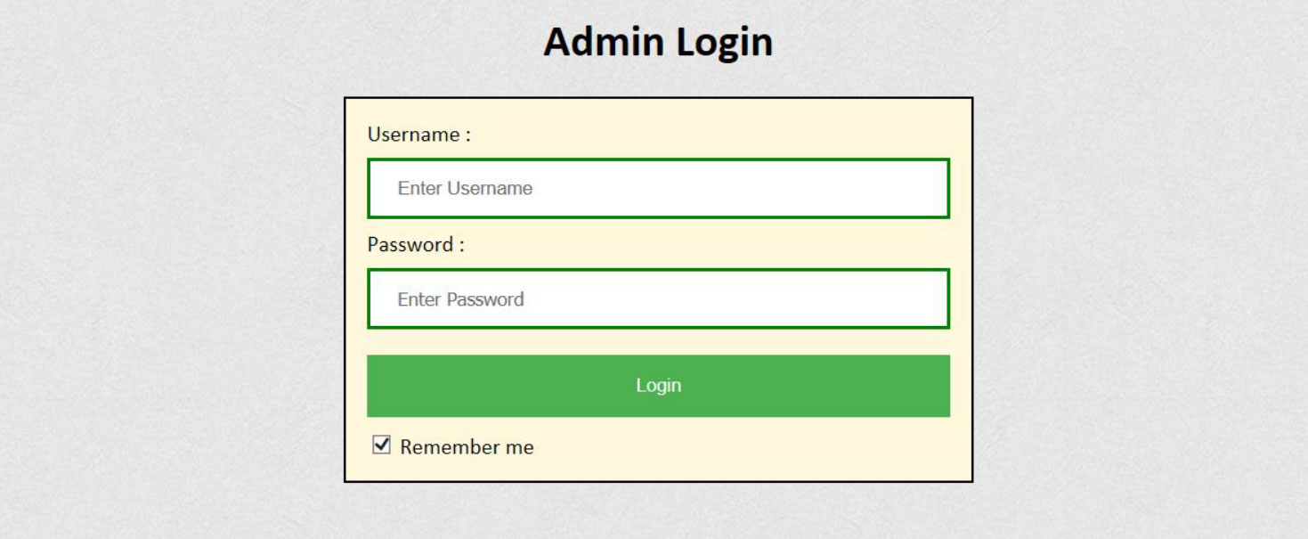

**Classes:-**

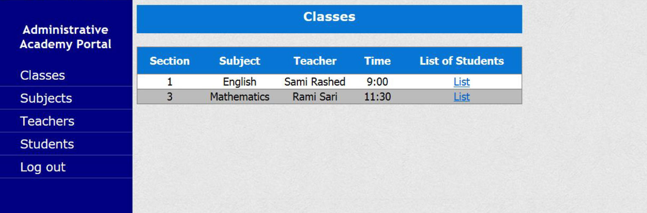

**Students of classes:-**

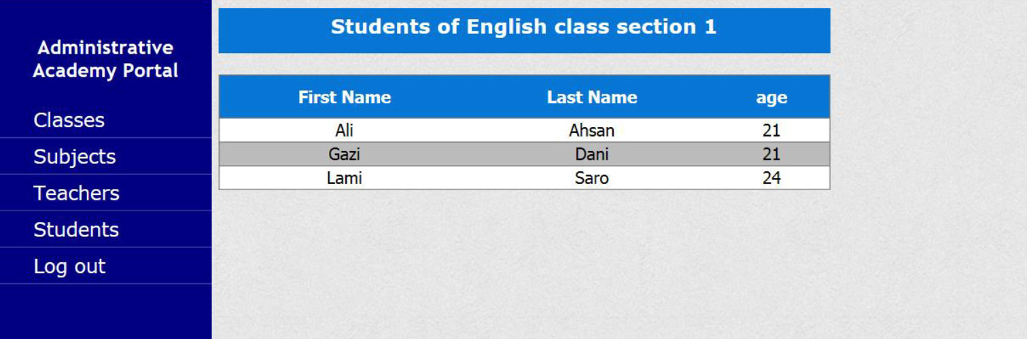

**Sujects:-**

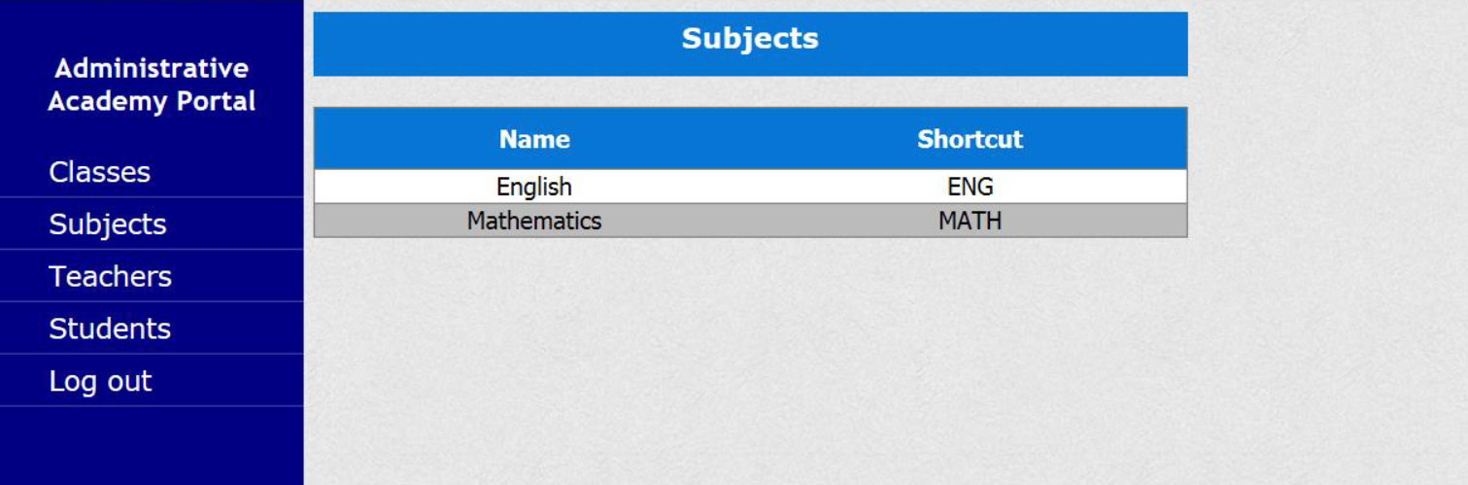

**Teachers:-**

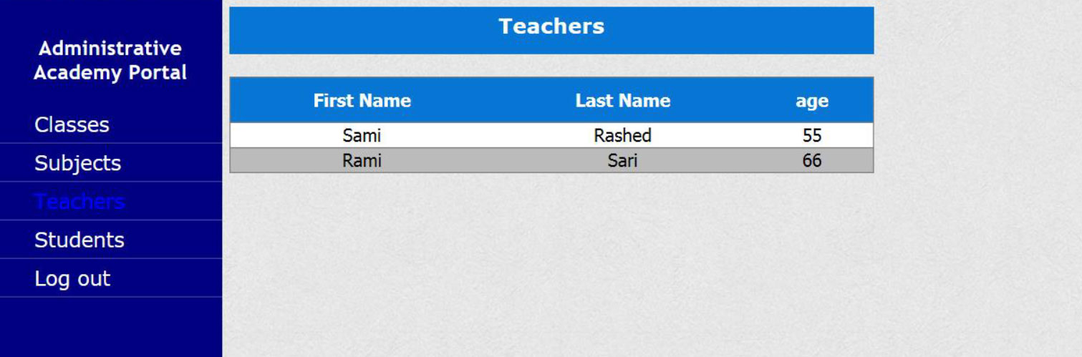

**Students:-**

